Non-invasive positive pressure ventilation mask to minimize mask leak and potential aerosolization leading to spread of virus such as COVID-19

Engineering Team:

Wes Rhiger¹, Bethany Brasser¹, Derek Wilson¹, Kipp Eaton¹, Lawrence Nugent¹, Nick Edwards¹, Ray Szeto¹, Tyler Finlayson¹

Medical Team:

Benjamin Thomson², Azad Mashari³, Scott Anderson⁴, Tarek Loubani⁴

¹General Dynamics Land Systems Canada, London, Ontario
²Mackenzie Health, Richmond Hill, Ontario
³Toronto General Hospital, Toronto, Ontario
⁴London Health Sciences Centre, London, Ontario

Background
A major challenge associated with Coronavirus Disease (COVID-19) is the demand it places on the use of invasive ventilators. Traditional non-invasive ventilation strategies, such as Continuous Positive Airway Pressure (CPAP) and Bi-level Positive Airway Pressure (BiPAP) vent directly to the atmosphere due to masks that are not fully sealed.
Few studies have been done on the potential harm caused by aerosolization from non-invasive ventilation. The data available suggest that caution must be taken with acute respiratory infection (ARI) patients when placing them on non-invasive ventilation such as CPAP or BiPAP due to excess risk to health care workers. This advice is being heterogeneously applied during the recent COVID-19 pandemic, with some practitioners advocating the use of non-invasive ventilation. The American Society of Anesthesiology presents some typical advice:
“In patients with acute respiratory failure, it may be prudent to proceed directly to endotracheal intubation, because non-invasive ventilation (e.g. CPAP or BiPAP) may increase the risk of infectious transmission.”
There is a role for non-invasive ventilation in COVID-19 negative patients during the pandemic, although practitioners are reluctant to initiate these measures because of the slow speed, lack of reliability and lack of availability of the viral swab confirming corona virus status.
The lack of non-invasive ventilation as an option in the clinician's arsenal leads to increased ventilator days that would previously have been bridged with non-invasive machines. The use of a closed-loop BiPAP machine in which no expired air is released into the environment would solve these problems.

Objective
This project seeks to develop and validate a solution to allow the use of non-invasive positive pressure ventilation (NIPPV) machines for patients that have COVID-19, or similar symptoms. In order to be used against COVID 19, the solution must:
- Drastically reduce risk of aerosolization of the COVID-19 virus
- Provide sufficient sealing around the mouth and nose to maintain CPAP/BiPAP effectiveness
- Filter patient exhaust with an N95 (or better) medical grade filter
- Be easy to produce in resource constrained locations

The COVID-19 pandemic has spurred many developments in this area, from adapting full-face snorkel masks to placing patients in hyperbaric therapy helmets. Though somewhat effective, the sealing of the snorkel masks has been determined inferior and the masks, now popular, are in short supply. Hyperbaric helmets have also become in demand resulting in limited available supply of an uncommon medical device.
London Health Sciences Centre has predicted the number of local COVID-19 cases to reach a critical level by mid April, requiring approximately 100 mask solutions. Some models predict up to 5000 patients will require simultaneous non-invasive ventilation province wide shortly thereafter.
The medical team named the solution “MAIN COVID-19 Mask” (Minimizing Aerosolization in Non-invasive ventilation in COVID-19).

Team Members
The engineering team from General Dynamics Land Systems is composed of 8 core contributors, and a number of part-time contributors, with a spectrum of expertise in administration, logistics, engineering, production, and distribution.
The medical team is composed of
- Dr. Ben Thompson – Medical Lead, Nephrologist at Mackenzie Health, and an Adjunct Professor at Queen’s University
- Dr. Azad Mashari – Department of Anesthesia and Pain Management, Toronto General Hospital, University Health Network; Assistant Professor at University of Toronto
- Dr. Tarek Loubani – Principal Investigator and Sponsor; and Medical Director for Glia. Glia provides Open Source medical supplies to resource constrained countries. Dr. Loubani is an Associate Professor at Western University

Roles and Responsibilities

Engineering team
- Project Management, Engineering, Proof-of-Concept manufacture, Supply Chain Management

Medical team
- Medical expertise, patient safety. requirements definition, ethics and regulatory approvals, Application testing, grant applications

Solution Use Cases
The proposed solution is intended for use in emergency rooms, intensive care units, prehospital transport, intra- and inter-hospital transport, and remote nursing stations. The following Use Case descriptions are provided to help illustrate the benefits of the MAIN COVID-19 Mask solution in real world situations.
This device will be used with:
- Supplemental oxygen from flowmeter (either wall oxygen or oxygen concentrator).
- Continuous Positive Airways Pressure (CPAP) and Bi-Level Positive Airway Pressure (BiPAP) non-invasive ventilator which has built in systems for controlling oxygen supplementation and managing and measuring pressures.
- Either of 1 or 2, with nebulized medications

Use case 1: Remote Nursing Station:
“Bruce” is a 48 year old police officer who presents with breathing difficulty to the nursing station at Mishkeegogamang First Nation, a group of communities with a total population of 1500 approximately 250 km from Sioux Lookout where the nearest hospital is located. The nursing station is staffed by experienced nurses, with physician support available by telemedicine and intermittent visits by family physicians from Sioux Lookout.
The nursing station is equipped with a transport ventilator, 2 oxygen concentrators with maximum flow rates of 3LPM and 10LPM respectively. No Oxygen tanks are available. On assessment the nurse is concerned that Bruce’s oxygenation is deteriorating rapidly. He contacts the physician on call in Sioux Lookout who determines that Bruce will likely require intubation, mechanical ventilation and transfer to an intensive care unit in either Thunder Bay or Sudbury.
The on-call physician has to fly into the community to intubate the patient for transfer. An air ambulance is also scheduled, but both flights are delayed for several hours due to high demand in the Sioux Lookout Zone. Bruce is not able to maintain adequate Oxygen saturation on nasal prongs at 4 Liters per minute, and it may take 8-12hrs for the on-call physician to arrive.
Current Path: Due to concerns with aerosolization, Bruce cannot be placed on high flow nasal oxygen. Bruce remains on nasal prongs and nurses do best to keep him comfortable.
Proposed Path with MAIN COVID-19 Mask: Apply MAIN COVID-19 mask along with high-flow oxygen.

Use case 2: Patient presenting with shortness of breath to emergency room
“Betty” is a 62 year old bank executive who comes to the emergency room triage desk with shortness of breath. Her vital signs (blood pressure, heart rate, respiratory rate, oxygenation status) are measured and her oxygen levels are low (85% on room air). Supplemental oxygen is provided by nasal prongs and Betty is placed in a room inside the main emergency room area.
She has blood tests, and is monitored every 15 minutes with vital signs and health care worker assessments. However, over the period of several hours, her oxygen requirements increase, and blood work confirms that she requires more than either standard or high flow nasal prongs can provide. The next step in providing additional respiratory support to Betty is non-invasive positive pressure ventilation (CPAP or BiPAP).
Current Path: Hospitals currently have a policy that patients presenting with symptoms consistent with COVID will not be offered NIPPV to prevent spread of the virus. Doctors must assume that anyone with symptoms comparable with COVID has the disease. Patients with COVID are often intubated for shortness of breath and connected to an invasive ventilator.
Proposed Path with MAIN COVID-19 Mask: With a device that reduces aerosolization of potential aerosol-borne viruses, health care workers will be able to administer the logical next step in providing additional respiratory support to Betty via NIPPV (CPAP or BiPAP). Betty may be on this treatment for anywhere from 2 hours to 5 days.

Use case 3: Intensive Care Unit with severe shortage of ventilators

Three weeks after the first case of COVID presented to a large academic hospital, all intensive care units, operating rooms and acute care areas in the hospital have been converted into ventilated wards. There is a severe shortage of ventilators with many patients sharing ventilators using experimental devices. Several patients with moderate but progressive hypoxic respiratory failure will likely require invasive ventilation in the next 24 hours. At the same time there are several ventilated patients who have largely recovered but still require low to moderate levels of positive pressure to adequately oxygenate.
Current Path: Doctors are forced to choose between which patients get invasive ventilation based on severity of symptoms and likelihood of recovery. These patients may not be COVID positive but due to the possibility of carrying the virus, and risk of aerosolization, they cannot be placed on NIPPV machines.
Proposed Path with MAIN COVID-19 Mask: Use the currently idle NIPPV machines along with MAIN COVID-19 Mask on low to moderate respiratory cases, and reserve invasive ventilators for more extreme cases.

Accomplishments to Date
- Project kicked off March 28th.
- Established requirements. See Appendix 1.
- Conducted an industry-wide search for all commercially available full face mask options (medical, chemical, scuba, oil & gas, firefighter). Decided on the use of 3M Scott Firefighter mask (AV2000 model) due to robustness of design, double sealing, and available stock.
- Selected the Medical DAR filter as it exceeds N95 filtering requirement, is in abundant supply within Hospitals, and is currently used in respiratory therapy systems.
- By leveraging 3D Printing, we conducted first Proof-of-Concept test within 48hrs of project kick-off and rapidly prototyped 6 iterations (in as many days) based on feedback from GDLS Engineers, medical team, and hands-on testing by Respiratory Therapists (RT). See Figure 1.
  - Decided to limit 3D printing material options to ABS and PETG as both are commonly used already in medical equipment.

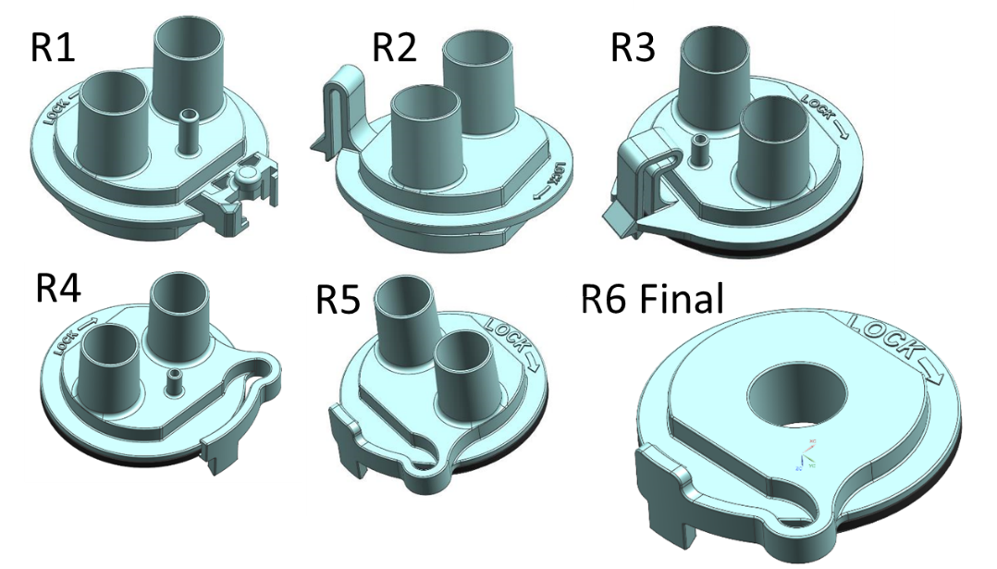
Figure 1 – ABS/PETG 3D Printed Adapter Versions

- Identified sources of supply, and received quotes for masks, gaskets, and 3D printed material.
- Conducted successful instrumented pressure and leak tests to operational limits.
  - Also, conducted successful characterization testing to quantify impact of patient coughing. Performance was deemed acceptable. See Figures 2 through 4.
- Provided mask kit to medical team to conduct testing with RTs on Thursday, April 2nd.
  - RTs successfully tested on different face sizes, machines, and circuit configurations with good results. Testing resulted in simplified circuit and adapter design. See Figure 5.
- Provided 4 prototypes to London Health Sciences Center (LHSC) on Saturday, April 4th. Further protocol and process testing was successfully completed. LHSC leadership provided support to continue after witnessing testing.
- Completed porosity testing on 3DP printed adapters with 20%, 40%, 60%, 80%, and 100% infill. See Figure 6.
- Received first order of 100 masks on April 8th, placed follow on order for the remaining 900 masks.
- LHSC submitted Ethics Application which must be approved before clinical trials on patients.

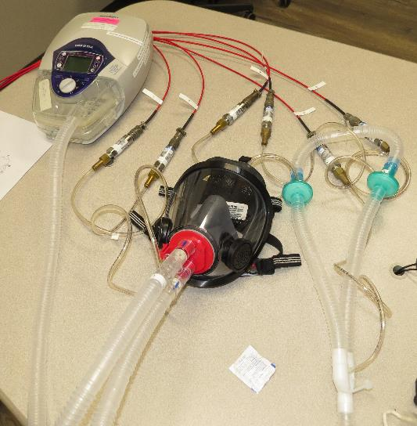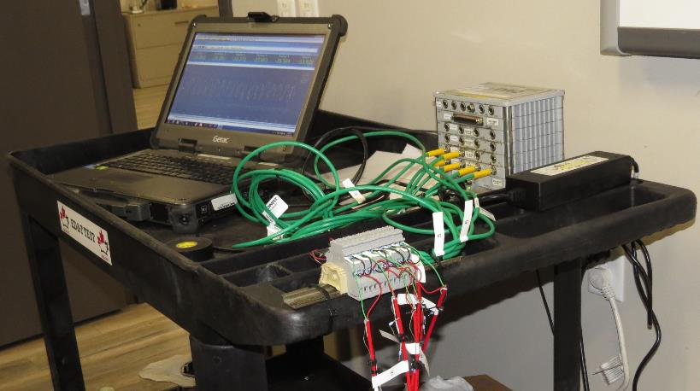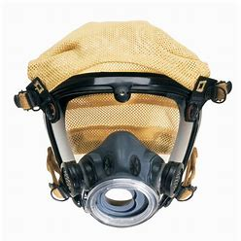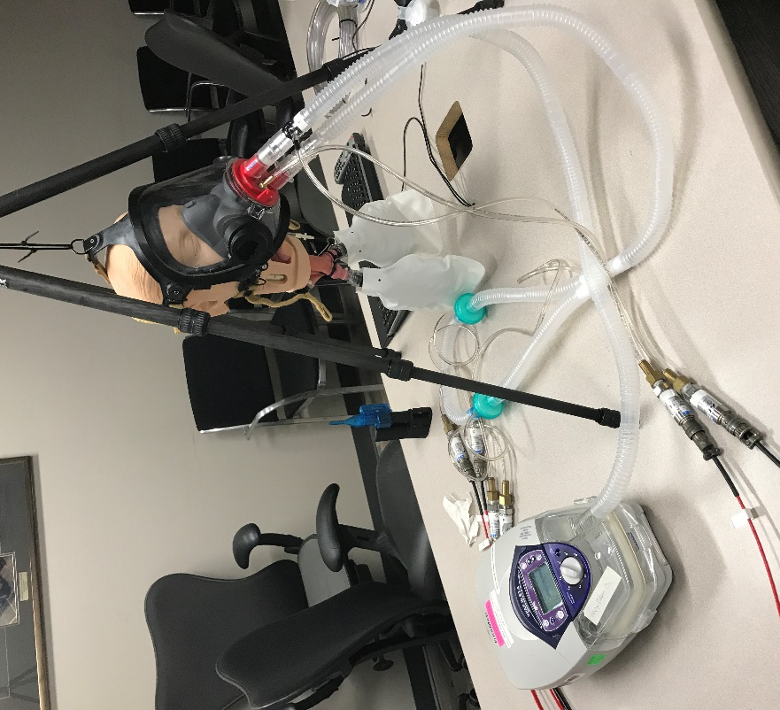
DAR Filters
3M Mask
3D Printed Adapter
CPAP

Figure 2 – Components of System and Test Set-up
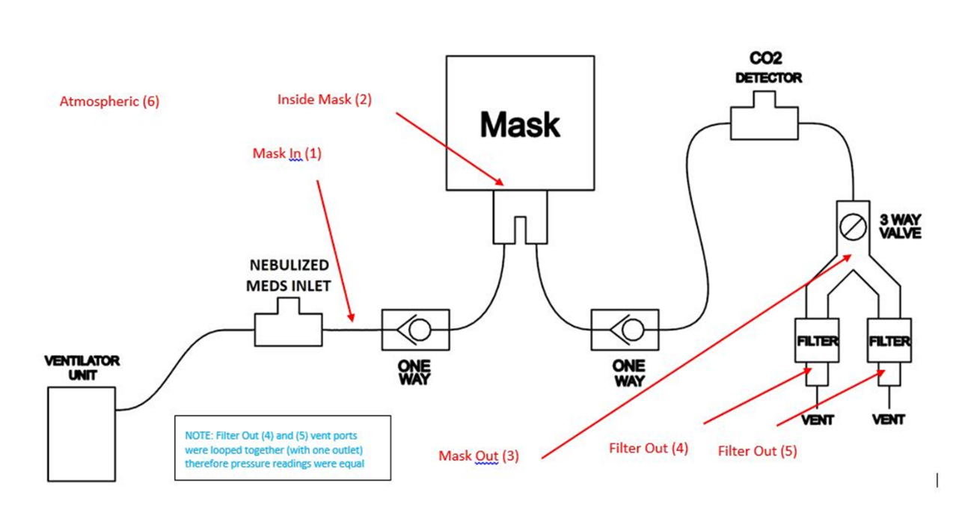
Figure 3 – Pressure Measurement Locations

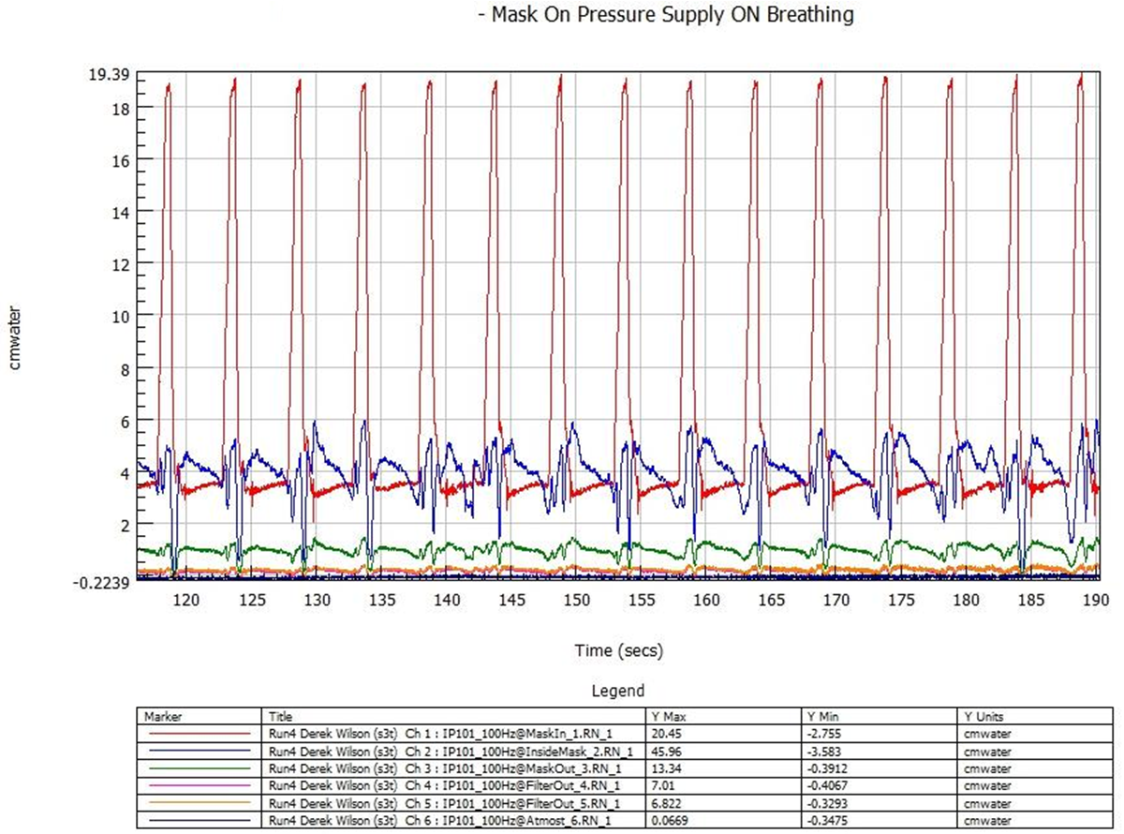

Figure 4 – Actual Pressure Measurement Readings – 5cm to 20cm BiPAP settings

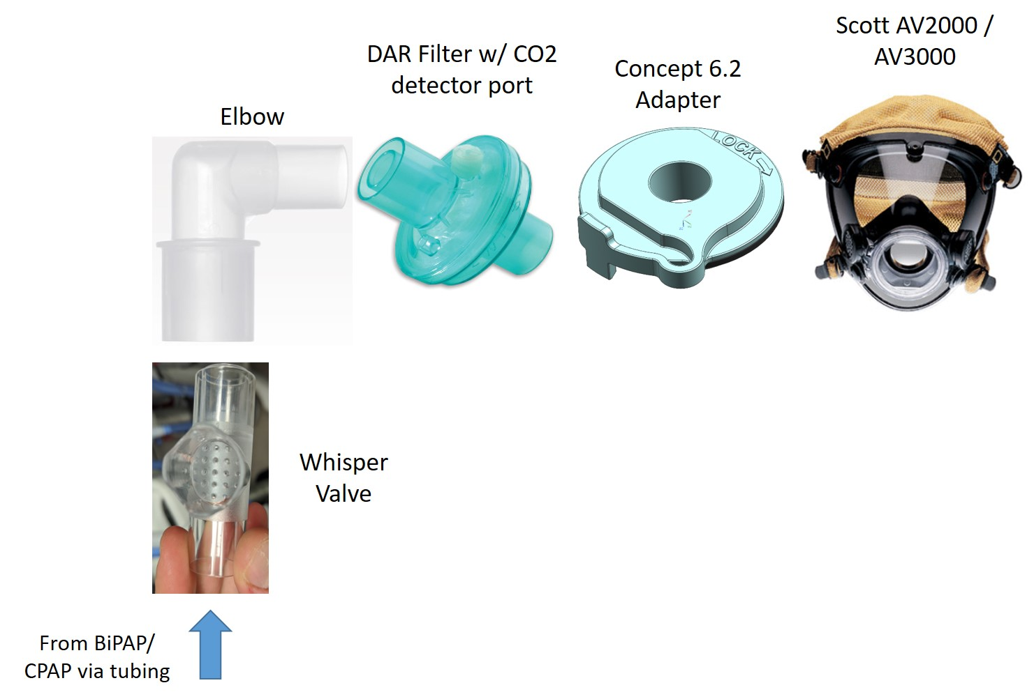
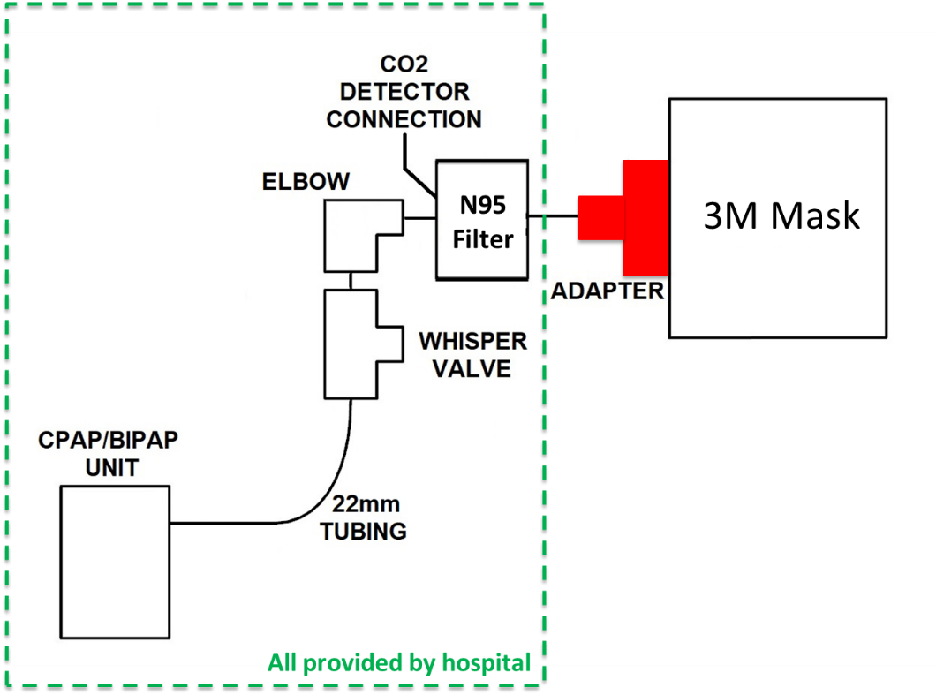

Figure 5 – Final Simplified Respiratory Circuit

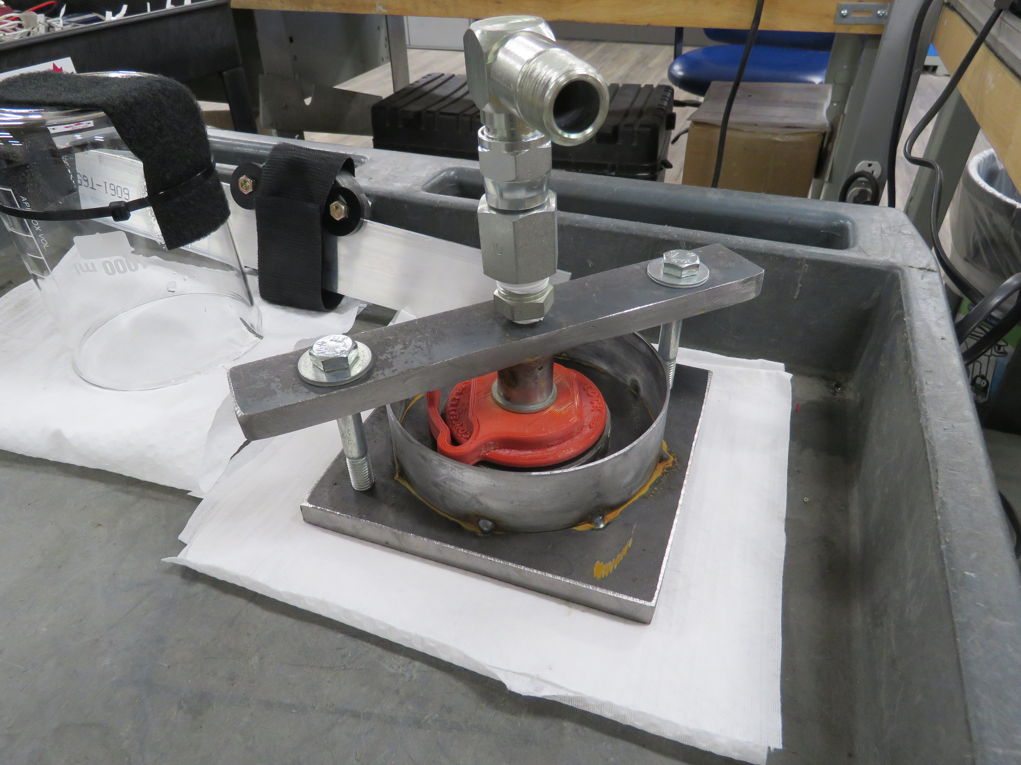
Surround with water and look for bubbles around red adapter.
Pressurize to 30cmH20

Figure 6 – 3DP Adapter Porosity testing

Next steps

- Complete application and user guidance documentation.
- Once internal LHSC Ethics Application has been approved (estimated April 9th), the Medical Team will conduct their first testing on patients, in a controlled environment. Expecting to conduct 2 days of patient testing.
- Assuming controlled patient testing is successful, plan is to expand use across both London hospitals (University Hospital and Victoria Hospital). Predictive models identify April 15th as a date during which demand for invasive ventilation exceeds capabilities.
- Demonstrated success in both hospitals will then open opportunity to expand across Ontario and North America.

Medical viability
The COVID-19 virus is spread primary with respiratory droplets, inhaled through one’s nasal or oral cavity into the respiratory tract. Aerosolization of respiratory droplets has also been identified as a major mechanism of transmission, and droplets containing virus can remain airborne for several hours. Procedures that aerosolize the COVID-19 virus significantly increase risk of transmission to health care workers. These procedures include placement and movement of a mask for NIPPV, suctioning upper airways and intubation of a patient for invasive ventilation. Given the concerns of aerosolization of viral particles, the American Society of Anesthesiology has recommended against use of NIPPV when a patient is suspected to have COVID19.
Hospitals address these concerns in one of two ways. Firstly, patients may simply not be offered NIPPV, and instead are intubated and placed on a standard ventilator. This increases demands on an already scarce resource (invasive ventilators), while worsening patient outcomes when placing on a more aggressive therapy than necessary. The alternative option is to use the aerosolizing standard mask with NIPPV, and accept the risk this poses to health care workers and other patients.
The MAIN-COVID mask overcomes these challenges by providing a mask for NIPPV that reduces aerosolization. In doing so, a number of desirable outcomes emerge:
- Decreases use of standard invasive ventilators, currently a scarce resource
- Decreases health care worker associated infections
- Decreases patient morbidity and mortality associated with use of a more aggressive therapy (invasive ventilation) than necessary (NIPPV)

Patient Safety
The MAIN-COVID mask has been extensively tested. Testing has included:

- At General Dynamics Land Systems (GDLS), the MAIN-COVID19 mask test was evaluated and passed a smoke test in a test dummy, as previous described
- Pilot testing during which members of the research team were fit tested while wearing the mask, and supervised by respiratory therapists for mask leak at standard NIPPV pressures. Use of 5, 10, 15, 20 and 25 cm H₂O pressure did not leak from the mask.
- The MAIN-COVID19 mask was worn by standardized dummies in the GDLS lab, and no leak was found, using the spectrum of standard NIPPV settings.
- A pilot patient study is undergoing at Western University April 12 onwards. Based on healthy human subject data (on investigators), 100 units have already been purchased, with a commitment for an additional 200 units. This was based on the reviews of the pulmonary medicine, emergency medicine and critical care physicians who observed the MAIN-COVID19 mask testing, and were universally in support of its’ broader use
- Given the urgency of applying this essential technology broadly, a study will be ongoing during real-life application.

Regulatory Processes
An application is being submitted to Health Canada for a Class II license. However, hospitals in Canada are not currently required to have Health Canada approval to use a new device, so long as efforts are in place to minimize aerosolization. Similarly, in the United States, the Food and Drug Administration (FDA) is allowing manufacturers of certain FDA-cleared ventilator devices to make modifications without making a new 510(k) submission. The following FDA recommendation excludes the MAIN-COVID19 mask from 510(k) submission (6):

“The use of devices indicated for sleep apnea (including the noncontinuous ventilators delivering continuous positive airway pressure (“CPAP”) or bi-level positive airway pressure), provided that appropriate design mitigations are in place to minimize aerosolization”
A Clinical trial has been registered with clincaltrials.gov.
The project is under review with Western's Health Sciences Research Ethics Board (HSREB) and with the Clinical Research Impact Committee (CRIC) at Lawson Health Science Institute.
References

- Doremalen N, Morris DH, Bushmaker T, Holbrook MG et al. Aerosol and Surface Stability
of SARS-CoV-2 as Compared with SARS-CoV-1. Correspondence with the Editor, New England Journal of Medicine. March 17 (2020): Available at: https://www.nejm.org/doi/full/10.1056/NEJMc2004973?url_ver=Z39.88-2003&rfr_id=ori:rid:crossref.org&rfr_dat=cr_pub%20%200pubmed

- World Health Organization. Coronavirus Disease 2019 (COVID-19) Situation Report- 66. March 26 (2020). Available at:https://www.who.int/docs/default-source/coronaviruse/situation-reports/20200326-sitrep-66-covid-19.pdf?sfvrsn=81b94e61_2

- Tran K, Cimon K, Severn M et al. Aerosol Generating Procedures and Risk of Transmission
of Acute Respiratory Infections to Healthcare Workers: A Systematic Review. Plos One 2012: 7(4): e35797. See Table 2, available at: https://www.ncbi.nlm.nih.gov/pmc/articles/PMC3338532/

- American Society of Anesthesiologists. COVID-19 Resources for Anesthesiologists:
Information for Health Care Professionals. Available at: https://www.asahq.org/about-asa/governance-and-committees/asa-committees/committee-on-occupational-health/coronavirus

- Hui DS, Chow BK, Lo T, Ng SS et al. Exhaled Air Dispersion During Noninvasive Ventilation via Helmets and a Total Facemask. Chest 2015: 147(5); 1336-1343. Available at: https://www.sciencedirect.com/science/article/pii/S0012369215383598

- U.S. Department of Helath and Human Services, Food and Drug Administration, Center for Devices and Radiological Health. Enforcement Policy for Ventilators and Accessories and Other Respiratory Devices During the Coronavirus Disease 2019 (COVID-19) Public Health Emergency: Guidance for Industry and Food and Drug Administration Staff. March 2020. Available at: https://www.fda.gov/media/136318/download

Appendix 1 – Initial Set of Requirements

Requirement | Compliance Statement
Solution shall allow connection of supplemental oxygen | Provided via the CPAP/BiPAP machine
Solution shall allow application of nebulized medications | Provide via appropriate adapter within 22mm respiratory circuit
Solution shall allow for ventilation through use of commonly available CPAP or BiPAP machines | Compliant
Solution shall allow for exit of 60 LPM outflow | Provided via the CPAP/BiPAP machine
Solution shall filter exhaust with N95 or better filter | Exceed requirement with medical DAR filters
Solution shall allow for testing of O₂/CO₂ levels | Provide via appropriate adapter within 22mm respiratory circuit
Solution shall prevent asphyxiation if CPAP/BiPAP is off | Provide via Whisper Valve within 22mm respiratory circuit
Solution shall cover eyes, nose, and mouth mucus membranes | Compliant with use of 3M Scot AV2000 Full Face Mask
Solution shall prevent escape of aerosolized particles while typically operating up to 25cmH₂O pressure, and a maximum of 30cmH₂0 | Compliant per test data
Solution should fit 5th percentile female up to 95th percentile male | Designed for use with Small, Medium and Large AV2000 Face Masks
Solution shall be free of latex | Compliant
Solution shall be compatible with typical cleaning/disinfecting procedures (70% ethanol, 0.5% hydrogen peroxide, 0.1% sodium hypochlorite) | Compliant
Solution shall be made available as open source | Compliant on 3DP adapter
Solution should minimize damage to patients skin after prolong use | Better than half face masks due to substantially larger sealing surface
Solution shall be tailorable to different mask solutions based on availability | Tested solutions that use 3M Scot AV3000 & AV2000, Honeywell 7600, and NATO Gas Mask
Solution shall be easy to produce/procure | Uses common hospital components, a commercially available mask, and easily producible 3D printed adapter
Solution shall connect to standard respiratory therapy hoses, fittings, and adapters | System designed to be integrated into a respiratory system using 22mm tapered fittings (ISO+5367-2014 & ISO 5356-1 (4e 2015))

